Margarita Chicken!

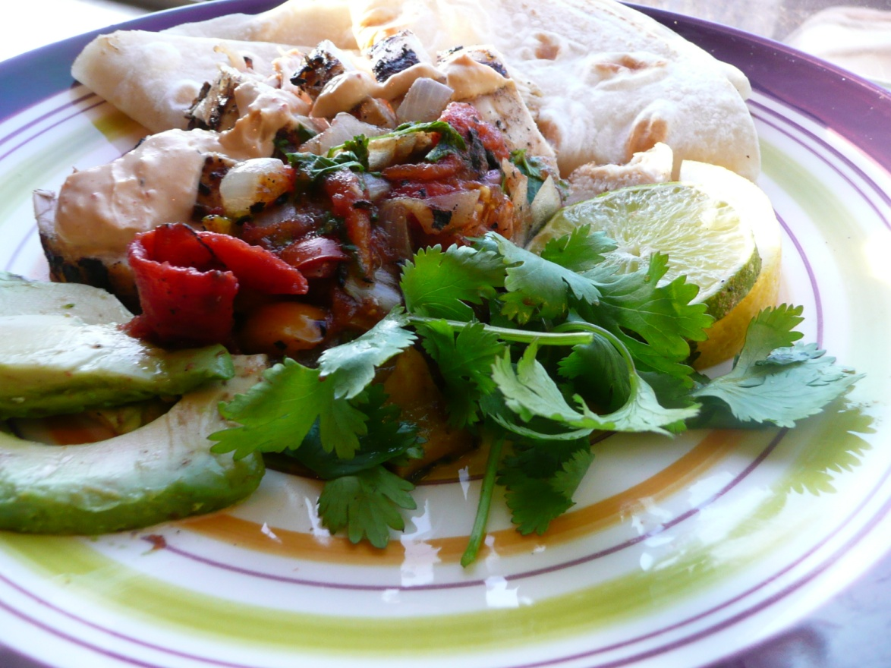

Serves six
Ingredients
2 pounds of boneless, skinless chicken breasts
1 cup of Margarita mix-no alcohol
1 orange, juice and orange zest
1 large lemon, juice and zest
2 limes, juice and zest
4 large crushed cloves of garlic
2 teaspoons of salt
½ cup vegetable oil
Directions
1. Butterfly open chicken to flatten. Cut chicken breast in half and place into a large Ziploc baggie. Add Margarita mix, orange, lemon and lime juice and zest, garlic, salt and oil to baggie. Mix ingredients. Place bag in refrigerator to marinate for at least ½ hour, or up to 4 hours.
2. Remove chicken from bag. If cooking outdoors, place chicken on a medium hot grill and cook until temperature reaches 160 or no longer pink. If using a pan on stove top, brown both sides of chicken. Let chicken rest for 3-4 minutes, cut into strips. Serve with Grilled Tequila Salsa and Avocado Cream.

Avocado Cream
Serves 6-8
Ingredients
8 ounces of Mexican Crema, sour cream, or Cooking Cream-garlic flavor
1 avocado mashed
1 fresh squeezed lime, about 3 tablespoons
Directions
Combine ingredients in medium mixing bowl until rich and creamy. Refrigerate until needed. Great served on tacos, burritos or even a fantastic chip dip!

